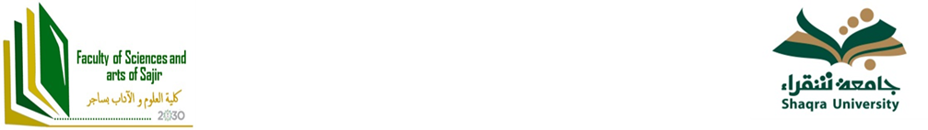
English Department
Syllabus
Course Title & Code : Modern Drama Najl 443

Credit Hours | 3 hours | Pre-requisites | Eng 181, Eng 251 and Eng 351
Course Objectives | This third course of drama focuses on showing students how modernism as a literary movement has affected the theatre in the late 19th century and early 20th century. It focuses on different literary theatrical movements within modern theatre like realism, naturalism, expressionism, feminism and the theatre of the absurd. It consists of a quick survey of the history of drama from the restoration period till 19th century melodrama and farce.
Course Topics
Learning Outcomes | Upon completion of this course, students will be able to: Define the characteristics of drama as a literary genre; Explain the reasons behind the emergence of modern drama; Discuss briefly the history of drama from the restoration era till the end of the Victorian era with an emphasis on the major changes in religion, politics, philosophy, dramaturgy and public taste for drama; Analyze the form and content of modern plays; Make sound analogies and comparisons between different plays and different playwrights; Define elements of realism, naturalism, surrealism, expressionism and absurdity in relation to their social, political and philosophical backgrounds; Apply some of these elements to some modern plays; Write research papers/present papers on modern plays.
Assessment & Grades’ Scale | Mid-term 1 (20%) ;Research Project (20%) ;Participation & Attendance (10%);Final Exam (50%)
References
Henrik, Ibsen. A Doll’s House.
Osborne, John. Look Back in Anger.
Beckett, Samuel. Endgame.
Syllabus’s Accreditation

