**The Impact of Mobile Applications on Foreign Languages Acquisition: A Pedagogical Perspective**

The onset of mobile applications has changed language learning, providing new chances for acquiring foreign languages. This paper examines the impact of mobile applications on foreign language acquisition from a pedagogical perspective. It explores how the integration of mobile technology in language learning encourages engagement, accessibility, and effectiveness for learners of different age groups and proficiency levels. Mobile apps offer individualized learning experiences through interactive features such as multimedia, gamification, content, and real-time feedback, making language acquisition more engaging and adjustable. moreover, the paper discusses the role of mobile applications in upgrading autonomy and self-directed learning, enabling learners to practice language skills outside traditional classroom environments. Despite the advantages, challenges such as the digital divide, over-reliance on technology, and the need for structured pedagogical frameworks are also addressed. The paper concludes by emphasizing the possibility of mobile applications as a valuable tool in foreign language education, suggesting that their pedagogical application requires careful combination into curricula for optimal learning outcomes.

**Keywords:** Mobile application, language acquisition, pedagogical perspective

1. **Introduction**

The fast promotion of technology has brought about crucial changes in education, particularly in the field of language learning. Mobile applications, especially, have emerged as powerful tools that enhance foreign language acquisition by providing interactive and individualized learning experiences. These apps rank the contiguity of mobile devices, enabling learners to practice language skills anytime and anywhere. The aim of this research paper is to explore the impact of mobile applications on foreign language learning from a pedagogical perspective. It will examine both the chances these tools provide and the problems they pose in the context of language acquisition.

1. **Literature Review**

**2.1 The Role of Mobile Applications in Language Learning**

Mobile applications have modified how foreign languages are taught and learned. One of the most notable advantages is the availability and adaptability they offer to learners. Traditional language learning often demands attending classes, and while this is adequate for many, it can be suppressive in terms of time and location. Mobile apps remove these obstacles by providing language learning transient opportunities, allowing learners to practice speaking, listening, reading, and writing at their own pace. **Godwin-Jones (2011)** examines the increasing role of mobile applications in language learning, providing insights into how mobile devices are altering the landscape of language pedagogy.

**2.2 Personalized Learning Experience**

One of the key benefits of mobile applications is the ability to offer individualized learning experiences. Through adjustable learning technologies, many apps adapt content to the user's level of proficiency and learning speed, offering a specialized experience that can improve retention. Applications like Duolingo, Babbel, and Memrise leverage this model to enhance the learner's experience by providing tailored lessons that cater to individual needs. This approach helps learners remain committed and motivated, as they can see their progress and receive instant feedback. Mobile applications can provide **personalized learning experiences** by adapting content based on a learner's proficiency level and offering real-time feedback, which helps customize the learning process (Chao, 2014; Rashid, 2019).

**2.3 Gamification and Engagement**

The use of **gamified elements** in mobile applications significantly supplements motivation, as learners are reinforced to complete tasks through points, levels, and badges (Rashid, 2019; Stockwell, 2010). Gamification, the combination of game-like elements into learning, has become a distinguished feature of many language learning apps. Games, levels, accomplishments, and rewards are used to stimulate learners to progress through lessons, making the process of acquiring a foreign language more funny and less dreadful. Research has shown that gamified elements can significantly expand learner motivation and control. For example, Duolingo's use of points, streaks, and levels keeps users motivated by providing immediate rewards for completing tasks, thus improving the learning experience. **Gamification** plays an important role in enhancing learner engagement by assembling game-like elements such as rewards, challenges, and competition (Chinnery, 2006; Godwin-Jones, 2011).

**2.4 Multisensory Learning and Multimedia Resources**

The use of **multimedia resources** in language learning offers an interactive context where learners can engage both visually and auditorily, reinforcing learning through different senses (Kukulska-Hulme & Shield, 2008; Thorne & Payne, 2005). Mobile applications typically involve a variety of multimedia resources such as images, videos, audio recordings, and interactive exercises. These resources gratify different learning styles (visual, auditory, kinesthetic) and help create a more exciting experience for the learner. For example, platforms like Fluent U use authentic videos (e.g., music videos, movie clips, news reports) to teach language, engaging learners’ ability to absorb natural speech and cultural nuances in real-world environments. According to **Chinnery (2006), multisensory learning** techniques—such as incorporating visuals, audio, and interactive elements—boost student retention and engagement, particularly when applied in language learning apps.

**2.5 Pedagogical Benefits of Mobile Applications**

**Pedagogical benefits** of mobile applications include the adaptability they provide to learners, allowing them to immerse with content at their own pace and in different learning contexts, increasing their autonomy and motivation (Stockwell, 2010; Viberg & Grönlund, 2013).The pedagogical implications of mobile applications are vast. Mobile technology, when properly integrated, can improve the overall educational experience and cause better learning outcomes. According to **Rashid (2019),** mobile applications offer **pedagogical advantages** by enabling learners to exercise language skills in various environments, encouraging better retention through immediate feedback and reinforcement. Below are some key pedagogical benefits:

**2.5.1 Promoting Autonomy and Self-Directed Learning**

According to **Chao (2014),** mobile applications support **autonomous learning** by facilitating learners engagement in learning activities independently, thus raising self-motivation and responsibility for their own progress. One of the most significant assets of mobile learning is the promotion of learner autonomy. Mobile applications enable students to take control of their learning process, selecting when, where, and how they study. This promotes self-directed learning, where students are accountable for their progress and success. This can be particularly effective for adult learners who may have not enough time or those who prefer to learn at their own pace. The use of mobile apps in education enhances **self-directed learning**, as they offer learners opportunities to control their time and learning goals while offering immediate feedback and resources (Chinnery, 2006; Rashid, 2019).

**2.5.2 Providing Immediate Feedback and Reinforcement**

Mobile applications are especially effective in **providing instant feedback and reinforcement,** enabling learners to correct mistakes and encourage their learning in real-time, which fosters retention and motivation (Godwin-Jones, 2011; Stockwell, 2010). Offering opportunities for continuous improvement. For example, an app may correct pronunciation errors, suggest better word options, or offer immediate translations. This real-time feedback supports, reinforce learning and correct mistakes, leading to more effective language acquisition.

**2.5.3 Collaborative Learning Opportunities**

Although mobile learning often accentuates individual learning, it can also enhance collaboration. Many apps feature social elements, such as leaderboards ,discussion forums , or features that allow users to associate with others learning the same language. These shared opportunities motivate communication skills and enhance social communication, which is critical for language learning. Stockwell, 2010; Viberg & Grönlund, 2013, agreed that mobile applications create **collaborative learning chances** by involving social media and interaction tools, allowing learners to work together in discussing topics, solving problems, and sharing learning experiences.

**2.6 Challenges and Limitations**

**Challenges** such as inconsistent internet connectivity and the diverse technical proficiency of learners can impede the effective use of mobile applications in language education (Kukulska-Hulme & Shield, 2008; Thorne & Payne, 2005). While mobile applications provide various benefits, there are also significant problems and limitations that must be addressed. These problems include the digital divide, over-reliance on technology, and the need for a balanced pedagogical approach.

**2.6.1 Over-Reliance on Technology**

According to **Thorne and Payne (2005),** one of the key flaw of mobile-assisted language learning is the possibility for **over-reliance on technology**, which may cause learners becoming too dependent on mobile apps, ignoring the need for interactive or immersive learning contexts. If learners depend only on mobile apps for their education, they may miss out on valuable face-to-face interactions, which are significant for mastering speaking and listening skills. Classroom interactions, cultural immersion, and direct feedback from a teacher remain important aspects of language acquisition that mobile applications cannot fully displace.

**2.6. 2 Digital Divide**

The **digital divide** remains a crucial barrier to the universal adoption of mobile-assisted language learning, as irregular access to technology can forbid learners from fully benefiting from mobile applications (Godwin-Jones, 2011; Kukulska-Hulme & Shield, 2008). Not all students have access to smartphones, tablets, or reliable internet connections, which can restrain their ability to benefit from mobile learning. This is a critical issue in developing countries or among economically disadvantaged groups, where access to mobile learning resources may be limited.

* 1. **3 Lack of Structured Pedagogy**

While mobile apps provide accessible access to language learning materials, they often fail to accord the structured pedagogical help necessary to ease systematic language acquisition, potentially restricting their educational value (Thorne & Payne, 2005; Chao, 2014). Without a well-designed pedagogical structure, learners may find difficulty in accomplishing comprehensive language mastery. Teachers must carefully curate mobile learning apps and incorporate them within the wide ranging context of a structured language syllabus to ensure that students benefit fully.

1. **Methodology of study**

the study adopts the descriptive analytical approach since it **describes** the impact of mobile applications on foreign language acquisition. This involves gathering detailed data on how mobile apps are used in language learning, the features they offer, and how learners perceive their effectiveness. By using a survey. The study also **describes** how mobile apps affect learners motivation, autonomy, and proficiency, and highlights problems such as the digital divide and over-reliance on technology. besides, describing the phenomenon, the study is also **analytical**, as it seeks to **analyze** the data to clarify relationships, and insights. The analysis involves examining the **impact** of mobile applications on language learning outcomes, using both quantitative and qualitative methods. For example, the study analyzes how engagement with different app features (like gamification or multimedia) relates to improved language proficiency or learner satisfaction. It also examines how learner characteristics (such as age or proficiency level) influence the effectiveness of mobile apps.

1. **Results and Discussions**

The sample of the study were the teachers and students of English department at Shaqraa university.

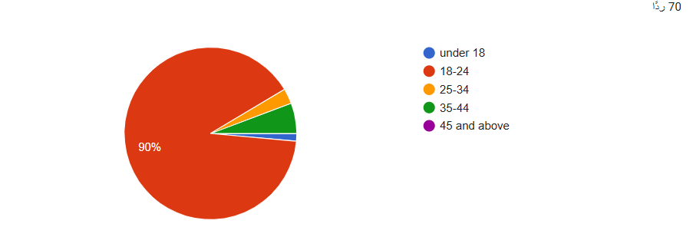

90% of the sample age is from 18- 24 years old.

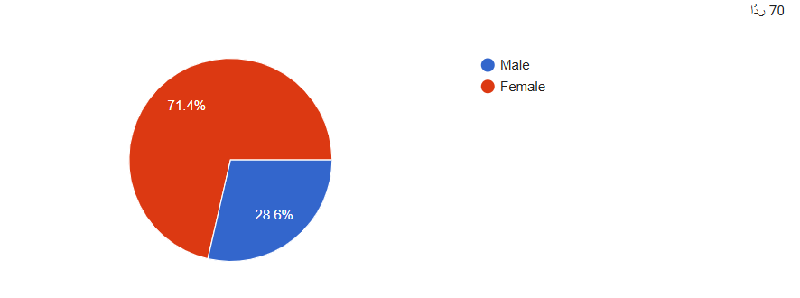Most of the participants 71.4% are female teachers and students.

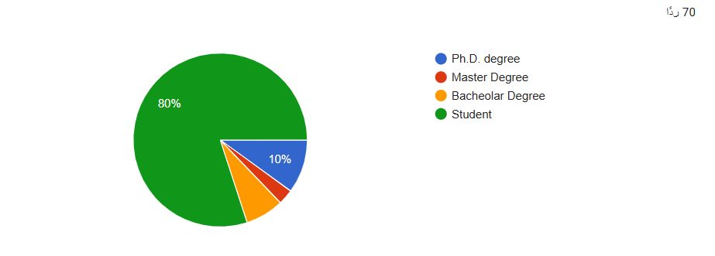The majority of the participants 80% are students.

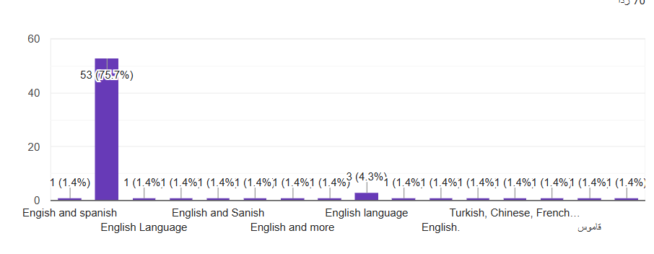The sample are learning different languages such as English, Turkish, French, Chinese, Spanish although most of them 60% are learning English language.

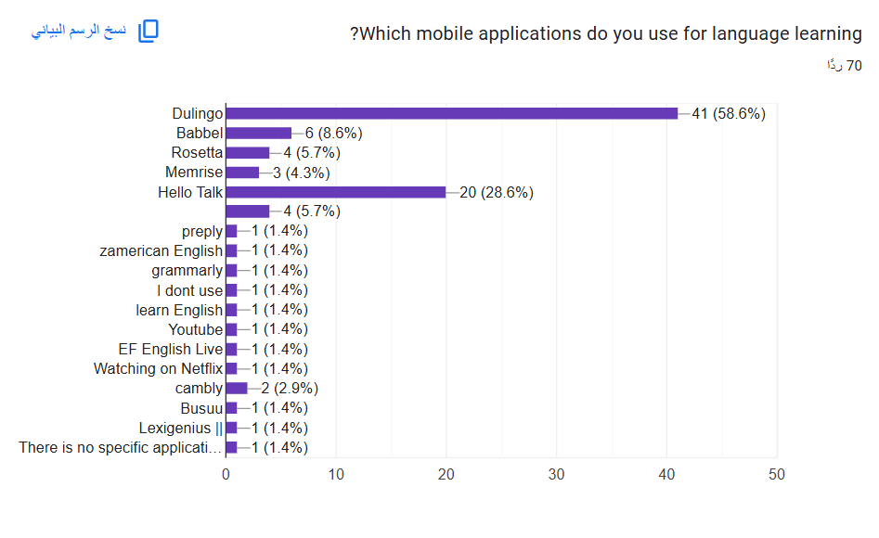The most popular mobile app is Dulingo. about 41% of the participants uses it.

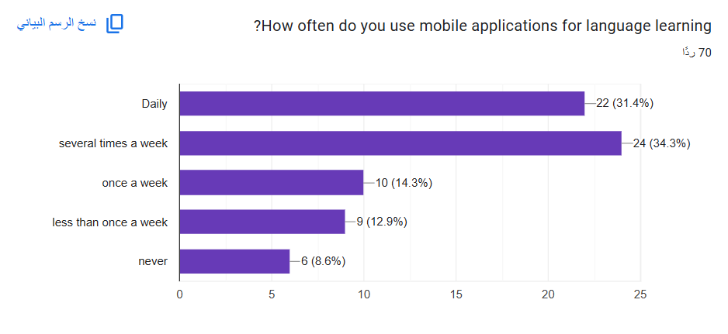Most of the participants are familiar with mobile applications and they use them daily (31.4%) or several times a week (34.3%) only (8.6%) of them never use mobile apps.

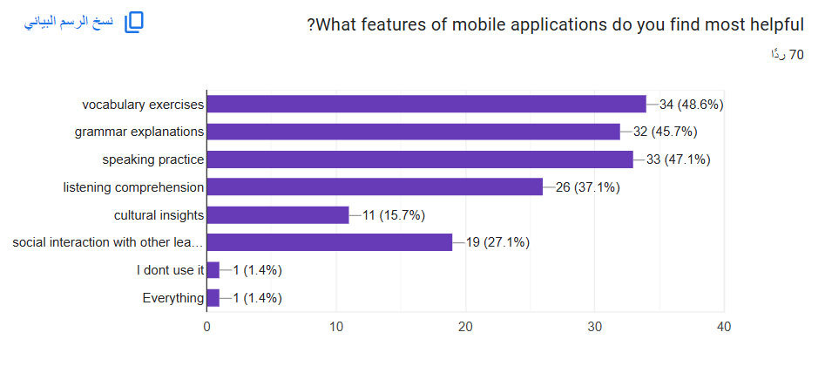

Although all the features are marked as most helpful but vocabulary exercises is chosen mostly (48.6%) followed by speaking practice (47.1%) and grammar explanation (45.7%).

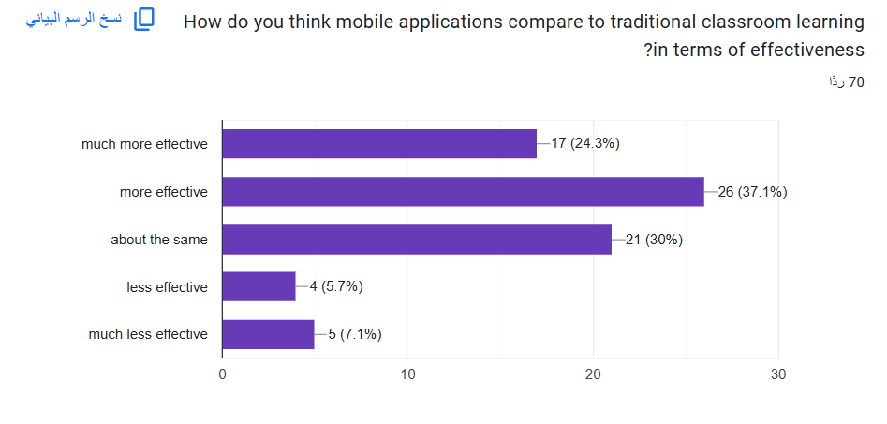

Most of the sample agree that learning a second language through mobile applications is more effective and much more effective respectively (37.1%) and (24.3%) than learning a second language through traditional classrooms.

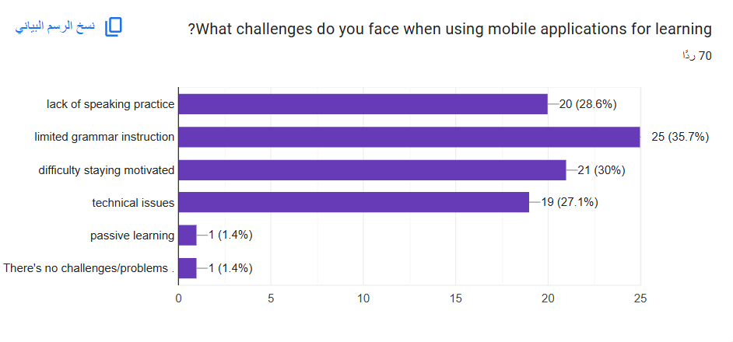The most important challenge the participants face is limited grammar instruction (35.7%) followed by lack of motivation (30%), lack of speaking practice (28.6%) and finally technical issues (27.1%) only two participants marked that it is a passive learning and there are no problems.

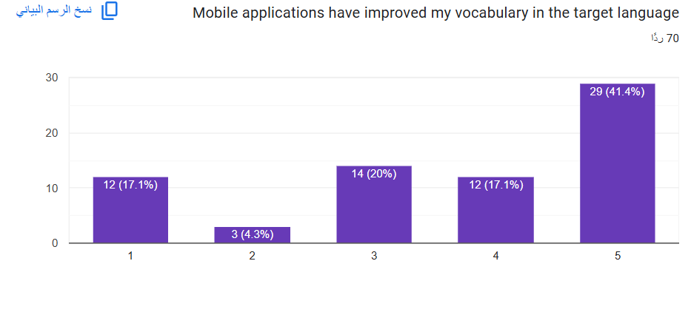Most of the participants 41.4% agree strongly that mobile apps improved their vocabulary, 17.1% of them agree with them too.

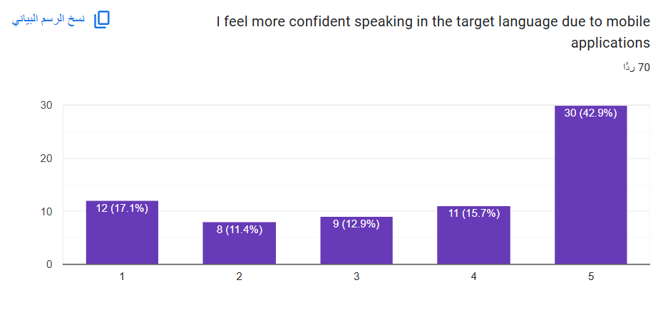

Most of the participants 42.9% agree strongly that mobile apps improved their speaking confidence, 15.7% of them agree too.

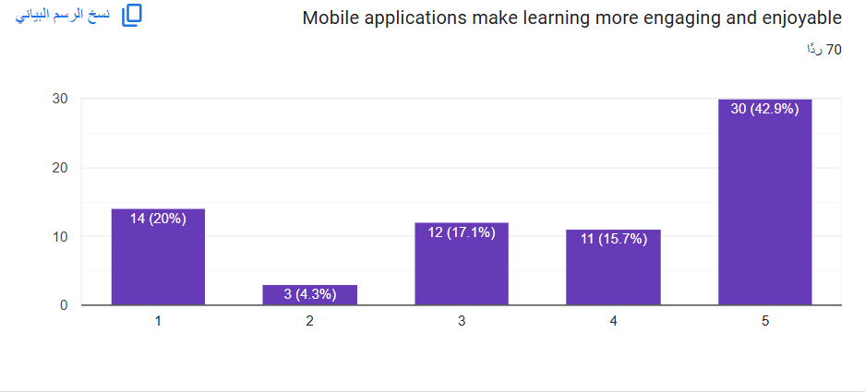

Most of the participants 42.9% agree strongly that mobile apps make learning more enjoyable, 15.7% of them agree too.

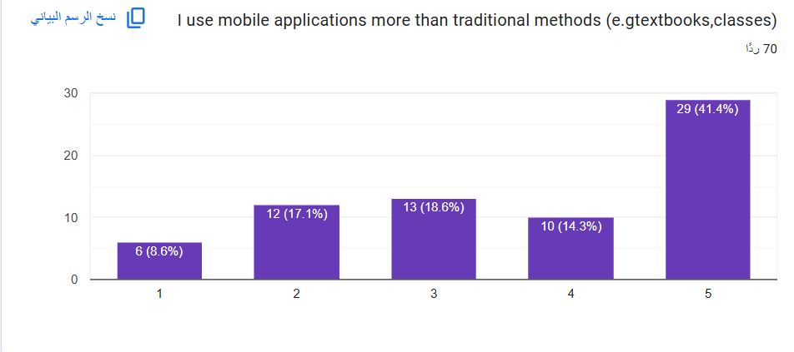**,**

Most of the participants 41.4% agree strongly that they use mobile apps more than traditional methods in learning a second language. 14.3% of the participants also agree that they often use mobile apps more than traditional methods of learning the second language.

**Conclusion**

The involvement of mobile applications into foreign language learning offers many opportunities for fostering student engagement, promoting autonomy, and offering individualized, flexible learning experiences. However, as with any pedagogical tool, mobile applications should be used in combination with other methods of language instruction to expand their advantages. Effective educational strategies are necessary to incorporate mobile apps semantically into the language learning process. Ultimately, when used correctly, mobile applications have the possibility to significantly improve foreign language acquisition, making language learning more available, enjoyable, and effective for learners all over the world.

**References**

• Chao, C. M. (2014). The use of mobile devices in language learning: A review of literature. International Journal of Information and Education Technology, 4(6), 506–510.

• Chinnery, G. M. (2006). Emerging technologies: Mobile learning. Language Learning & Technology, 10(1), 9–16.

• Godwin-Jones, R. (2011). Mobile apps for language learning. Language Learning & Technology, 15(2), 2–11.

• Kukulska-Hulme, A., & Shield, L. (2008). An overview of mobile assisted language learning: From content delivery to supported collaboration and interaction. ReCALL, 20(3), 271–289. https://doi.org/10.1017/S0958344008000335

• Rashid, S. (2019). Mobile-assisted language learning: The role of apps in the classroom. The Language Learning Journal, 47(2), 185-196. https://doi.org/10.1080/09571736.2018.1483144

• Stockwell, G. (2010). Using mobile phones in English education in Japan. ReCALL, 22(1), 35–57. https://doi.org/10.1017/S0958344009990196

• Thorne, S. L., & Payne, J. S. (2005). Evolutionary trajectories, Internet-mediated instruction, and international language education. CALICO Journal, 22(3), 371–397.

• Viberg, O., & Grönlund, Å. (2013). Mobile learning in developing countries: Exploring the role of mobile phones in education in Kenya. International Journal of Educational Technology in Higher Education, 10(3), 231–249. https://doi.org/10.1186/2252-2267-10-3