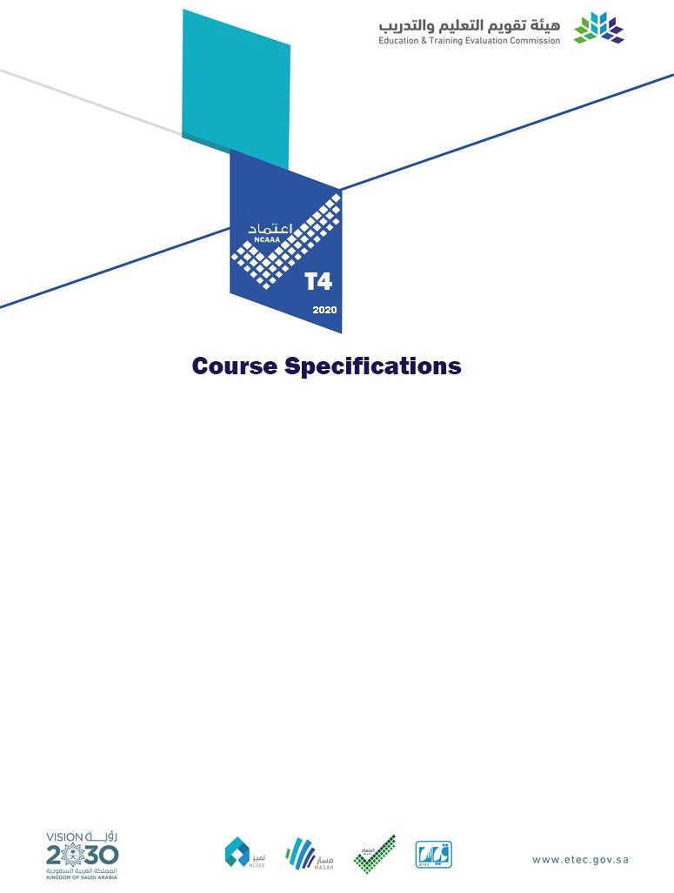
Course Title: | Patho-physiology
Course Code: | NUR 365
Program: | B. Sc. In Nursing
Department: | Dept. of Nursing
College: | College of Applied Medical Sciences in Al-Dawadimi
Institution: | Shaqra University

Table of Contents
- Course Identification 3
6. Mode of Instruction (mark all that apply) 3
- Course Objectives and Learning Outcomes 3
  - Course Description 3
: (Note: General description in the form to be used for the Bulletin or handbook should be attached) 3
  - Course Main Objective 3
  - Course Learning Outcomes 4
- Course Content 4
- Teaching and Assessment 6
  - Alignment of Course Learning Outcomes with Teaching Strategies and Assessment Methods 6
  - Assessment Tasks for Students 7
- Student Academic Counseling and Support 7
- Learning Resources and Facilities 8
  - Learning Resources 8
  - Facilities Required 8
- Course Quality Evaluation 8
- Specification Approval Data 9

Course Identification

1. Credit hours: |  | 3 (3+0+0)
2. Course type
a. | University |  | College |  | Department |  |  |  |  | √ | Others
b. | Required |  | √ | Elective
3. Level/year at which this course is offered: |  |  |  |  |  |  |  |  | level 6 (3rd year )
4. Pre-requisites for this course (if any): NUR232+NUR241
5. Co-requisites for this course (if any):NUR351
- Mode of Instruction (mark all that apply)
No | Mode of Instruction | Contact Hours | Percentage
1 | Traditional classroom
2 | Blended | 3 X 15 =45 | 100%
3 | E-learning
4 | Distance learning
5 | Other

- Contact Hours (based on academic semester)
No | Activity | Contact Hours
1 | Lecture | 45 hours
2 | Laboratory/Studio | 0
3 | Tutorial | 0
4 | Others (specify) | 0
 | Total | 45

Course Objectives and Learning Outcomes
1. Course Description
: (Note: General description in the form to be used for the Bulletin or handbook should be attached)
This theoretical course introduces nursing student to the mechanisms and theories related to the development of disease and alteration in body function of individuals throughout their life span. Common conditions related to functional health patterns and immunological responses are also addressed.
2. Course Main Objective
Discuss selected concepts and theories of pathophysiology, Integrate the etiology, pathophysiology, signs and symptoms, and clinical rational for treatment of selected diseases across the lifespan

3. Course Learning Outcomes

CLOs | Aligned PLOs
Knowledge:
The student will be able to state and to describe the terms related to Pathophysiology. | p.
Each student will be able to define the common diseases and its signs and symptoms. | p
Skills :
Each student will be able to explain the different pathophysiologic  process in a disease | m
Each student will be able analyze the signs and symptoms of the disease | M
Values:
use the knowledge in explaining or communicating using non medical  terms of the disease to different age group and in various settings | p`
Define the different diseases and its definition | p

Course Content
No | List of Topics | Contact  Hours
1 | Pathophysiology  - Key principles of pathophysiology  - Cell injury, adaptation and death  - Inflammation, tissue repair and regeneration  - Cancer | 3
2 | Shock  - Cardiogenic shock  - Anaphylactic shock  - Hypovolaemic shock  - Septicaemia | 3
3 | - Human immunodeficiency virus  - Non-Hodgkin lymphoma  - Infectious mononucleosis  - Quiz 1 | 3

4 | The nervous system  - Meningitis  - Multiple sclerosis  - Parkinson’s disease  - Cerebrovascular accident | 3
5 | The blood  - Anemia  - Deep vein thrombosis  - Leukemia  - Thrombocytopenia  - Midterm exam ( first ) | 3
6 | The cardiovascular system  - Heart failure  - Myocardial infarction  - Peripheral vascular disease  - Angina 56 | 3
7 | The respiratory system  - Asthma  - Chronic bronchitis  - Pulmonary embolism  - Chronic obstructive pulmonary disease | 3
8 | The gastrointestinal system  - Peritonitis  - Crohn’s disease  - Peptic ulcer  - Ulcerative colitis  - Bowel cancer  - Second midterm exam | 3
9 | The hepato - biliary system  - Hepatitis  - Cholecystitis  - Pancreatitis  - Liver cancer  - Quiz 2 | 3
10 | The urinary system  - Renal failure  - Pyelonephritis  - Renal calculi  - Bladder cancer | 3
11 | The male reproductive system  - Benign prostatic hyperplasia  - Testicular torsion  - Erectile dysfunction  - Prostate cancer  - Testicular cancer  The female reproductive system  - Cancer of the vulva  - Menorrhagia  - Breast cancer  - Cervical cancer
11 |  | 3

12 |  | The endocrine system  - Diabetes mellitus  - Adrenal insufficiency  - Cushing’s syndrome  - Hyperthyroidism  - Midterm exam (2) | 3
13 |  | The musculoskeletal system  - Osteoarthritis  - Osteoporosis  - Osteomyelitis  - Gout  - Rheumatoid arthritis  Skin  - Atopic dermatitisâ  - Psoriasisâ  - Acne vulgarisâ  - Malignant melanomaâ | 3
14 |  | Ear, nose and throat  - Otitis media  - Ménière’s disease  - Pharyngitis  - Rhinosinusitis  - Epistaxis | 3
15 |  | Vision  - Cataracts  - Glaucoma  - Age-related macular degeneration  - Conjunctivitis | 3
 | Total |  |  | 45

Teaching and Assessment

Alignment of Course Learning Outcomes with Teaching Strategies and Assessment Methods

Code | Course Learning Outcomes | Teaching Strategies | Assessment  Methods
1.0 | Knowledge
1.1 | Each student will be able to state and describe the terms in Pathophysiology course | Lecture, Discussion, Questioning, Using audio-visuals,  Interactive lecture | Quizzes, Graded Recitations, Examinations
1.2 | Each student will be able to define the different diseases and its definition | Lecture, Discussion, Questioning, Using audio-visuals,  Interactive lecture | Quizzes, Graded Recitations, Examinations

Code | Course Learning Outcomes | Teaching Strategies | Assessment Methods
…
2.0 | Skills
2.1 | Each student will be able to explain the different pathophysiologic process in a  disease | Lecture, Discussion, Using audio-visuals,  Interactive lecture | Quizzes, Graded Recitations,  Examinations
2.2 | Each student will be able analyze the signs and symptoms of the disease | Lecture, Discussion,  Using audio-visuals, Interactive lecture | Quizzes, Graded  Recitations, Examinations
…
3.0 | Values :
3.1 | use their knowledge in explaining or communicating using non medical terms of the disease to different age  group and in various settings | Demonstration, Interactive Lecture, Discussion | Oral Presentation, Graded Recitation, Examinations
3.2
…

Assessment Tasks for Students
*Assessment task (i.e., written test, oral test, oral presentation, group project, essay, etc.)
# | Assessment task* | Week Due | Percentage of Total Assessment  Score
1 | Quiz 1 | 3 | 5%
2 | Quiz 2 | 13 | 5%
3 | Assignment | 5 | 10%
4 | Midterm Examination1 | 6 | 15%
5 | Midterm Examination2 | 12 | 15%
6 | Final Examination | End of semester | 50%
7
8

*Assessment task (i.e., written test, oral test, oral presentation, group project, essay, etc.)

Student Academic Counseling and Support
Arrangements for availability of faculty and teaching staff for individual student consultations and academic advice :

Monday: 12:00pm- 2:00pm Thursday: 8:00am – 12:00pm

Learning Resources and Facilities

Learning Resources
Required Textbooks | 1. List Required Textbooks  Pathophysiology for Nurses at a Glance, First Edition. Muralitharan Nair and Ian Peate. © 2015 John Wiley & Sons, Ltd. Published 2015 by John Wiley &  Sons, Ltd.  Companion website: www.ataglanceseries.com/nursing/pathophysiology
Essential References Materials | (Journals, Reports, etc.)
Electronic Materials | Cochrane.org Pubmed.com  Joannabriggs.com
Other Learning Materials | LCD Projector  Computers Audiovisual materials

- Facilities Required
Item | Resources
Accommodation  (Classrooms, laboratories,  demonstration rooms/labs, etc.) | 1. Accommodation (Classrooms, laboratories, demonstration rooms/labs, etc.)  Classroom
Technology Resources  (AV, data show, Smart Board, software, etc.) | Computing resources (AV, data show, Smart Board,  ).software, etc LCD Projector Smart board  Audio equipment
Other Resources
(Specify, e.g. if specific laboratory equipment is required, list
requirements or attach a list)

Course Quality Evaluation

Evaluation Areas/Issues | Evaluators | Evaluation Methods
quizzes, midterm and final examinations | Faculty Member | Analysis of course reports & student's results
Quality of learning resources | Program administrators Quality Assurance experts | Internal reviewing of the course contents, outcomes, reports & student's results
Peer evaluation to assess  ability of faculty members. | members | Feedback from student

Evaluation Areas/Issues | Evaluators | Evaluation Methods

Evaluation areas (e.g., Effectiveness of teaching and assessment, Extent of achievement of course learning outcomes, Quality of learning resources, etc.)
Evaluators (Students, Faculty, Program Leaders, Peer Reviewer, Others (specify)
Assessment Methods (Direct, Indirect)

Specification Approval Data
Council / Committee
Reference No.
Date

